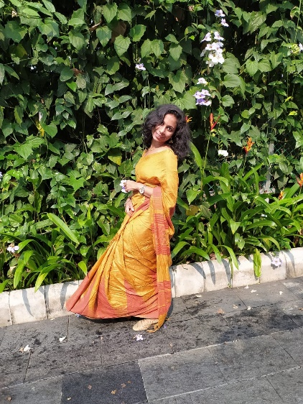

***ALEENA MARY V S***

***VADAKKAN HOUSE***

***TOYAKKAVU P O, THRISSUR, KERALA.***

***ABOUT ME!***

* ***I’ am 21 years old***
* ***I’ am Short and Pretty.***
* ***Pursuing MCA From Rajagiri College of Social Sciences, Kalamassery.***

***.***